Project Members:
1. Ali Hussein Ahmed
2. Abdelrady Elagamy
Section: 2

Emails:
Ali- fci04-041@fci.aun.edu.eg
alihussin.it@gmail.com

Abdelrady- abdelrady@gmail.com

Project Name:
SMART SCREEN SAVER- (SSS)

Description:
An application based on the recognition of human face during the use of the personal computer , once user had leave the computer for while, the Smart Screen Saver activated preventing any other unauthorized people from activating computer, once the authorized user arrived the Smart Screen Saver recognizes him and deactivates the computer lock.

Initially this application will deal only with the existence of human face, once human face detected (any human face) the Smart Screen Saver is deactivated, if there is no any face in the retrieved frames it will activated.

Details:
Application can be divided into four steps
- Capturing Data.
That concerns with capturing frames from the camera.

- Human face detection.
The determination whether there are Human faces in camera frames or not.

- Human face recognition.
Identification of the authorized user, this step will be delayed or omitted.

- Decision.
Lock Or Unlock PC Station.

Expected Application:
Before beginning to code application I prefer to Design GUI (fig 1) it’s not a final design but it is just the first step.

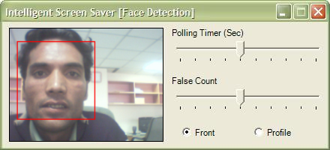

Fig 1 – Expected application.

Expected obstacles:-
- Recognition.
Tools:
- C#.net 2005
- OpenCV Library

Recommendations:
Comments on project in near time.
Signature:
Abdelrady Elagamy
Ali Hussein Ahmed.
IT Department.

THANK YOU for Reading

